**Mini Heat Pump Performance**

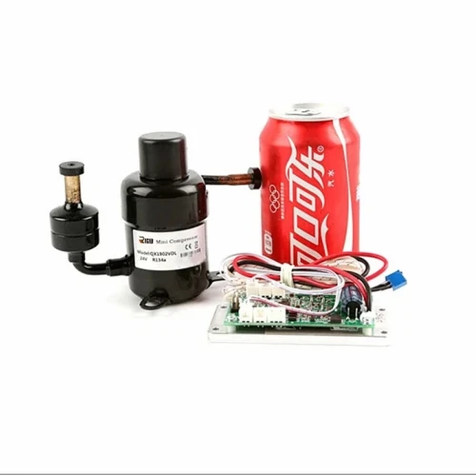

**Specifications**

* up to 450 W cooling capacity
* Up to 150 W power usage
* COP 3.0
* Up to 600 W heating capacity
* 12 VDC

**Infrared Thermal Imaging**

**Heating source Cooling source**

**\* Heating source up to 36 dC from the upper section of the condenser * Cooling source down to 3 dC from the evaporator**

**First Principle Thinking**

**Our Fundamental Question**

***WHAT* do we really want to HEAT or COOL?**

**WHY Heat Pump?**

**Do you know?**

* Combined heating & cooling in one unit
* High Coefficient of Performance (COP) to 3.0 above
* Using cleaner electricity and reduce GHG emissions
* Solar-assisted Heat Pump market size up to USD 140 billion